Bounded Region in Solid Geometry

Definition
# Source: AI Source: Provided by: [Data Path: Persons Table -> ID Column: 1, Name_En Column: Motasem Essam] -> From: [ChatGPT] on [7/25/2026]
A bounded region in solid geometry is a region of three-dimensional space that lies entirely within a finite distance from a fixed point or within some finite limits. In other words, it does not extend indefinitely in any direction.
A bounded region may be enclosed by flat surfaces, curved surfaces, or a combination of both. Examples include the interior of a cube, the region inside a sphere, and the space enclosed by a cylinder.
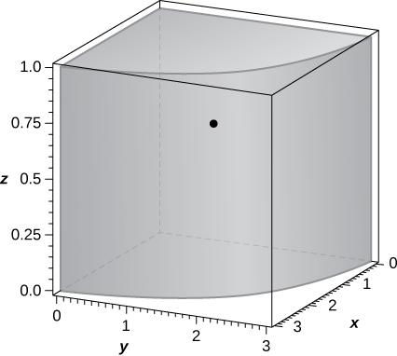
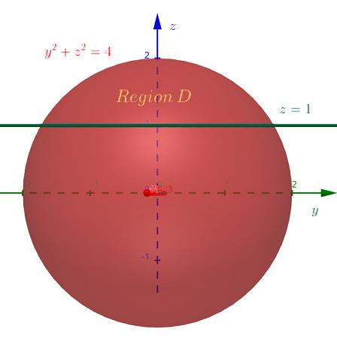
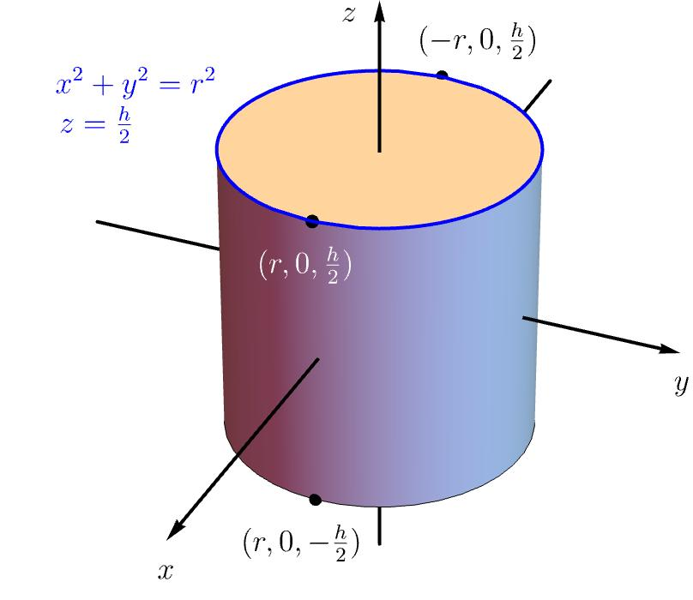

Simple Definition
# Source: AI Source: Provided by: [Data Path: Persons Table -> ID Column: 1, Name_En Column: Motasem Essam] -> From: [ChatGPT] on [7/25/2026]
A bounded region is a finite area of space that does not extend infinitely far.
For example:
- The interior of a cube is bounded.
- The space inside a ball is bounded.
- The region enclosed by a pyramid is bounded.
- The entire three-dimensional space is unbounded because it extends infinitely in every direction.
A bounded region can include its boundary, exclude its boundary, or include only part of it, depending on how the region is defined.

Classification
# Source: AI Source: Provided by: [Data Path: Persons Table -> ID Column: 1, Name_En Column: Motasem Essam] -> From: [ChatGPT] on [7/25/2026]
Types of Regions in Solid Geometry
Bounded Region
A region contained within finite spatial limits.
Examples: a cube's interior, a ball, a tetrahedral region.
Unbounded Region
A region that extends indefinitely in at least one direction.
Examples: a half-space, an infinite cylinder, all of three-dimensional space.
Boundedness is a property of a region, not a requirement that the region have a particular shape. A region can be bounded whether its boundary is flat, curved, smooth, or irregular.

Key Characteristics
# Source: AI Source: Provided by: [Data Path: Persons Table -> ID Column: 1, Name_En Column: Motasem Essam] -> From: [ChatGPT] on [7/25/2026]
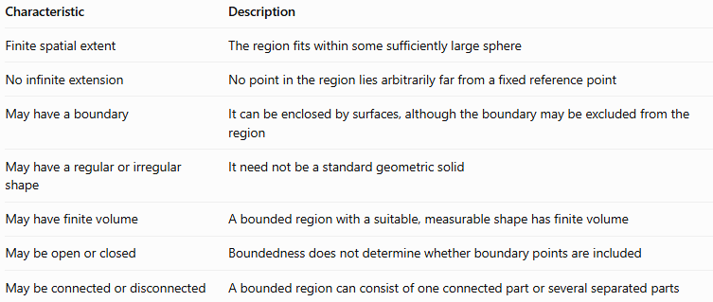
Characteristic | Description
Finite spatial extent | The region fits within some sufficiently large sphere
No infinite extension | No point in the region lies arbitrarily far from a fixed reference point
May have a boundary | It can be enclosed by surfaces, although the boundary may be excluded from the region
May have a regular or irregular shape | It need not be a standard geometric solid
May have finite volume | A bounded region with a suitable, measurable shape has finite volume
May be open or closed | Boundedness does not determine whether boundary points are included
May be connected or disconnected | A bounded region can consist of one connected part or several separated parts
Important distinction: Bounded does not automatically mean closed. For example, the interior of a sphere without its surface is bounded but open as a subset of three-dimensional space. The closed ball, including its surface, is bounded and closed.

Geometric Representation
# Source: AI Source: Provided by: [Data Path: Persons Table -> ID Column: 1, Name_En Column: Motasem Essam] -> From: [ChatGPT] on [7/25/2026]
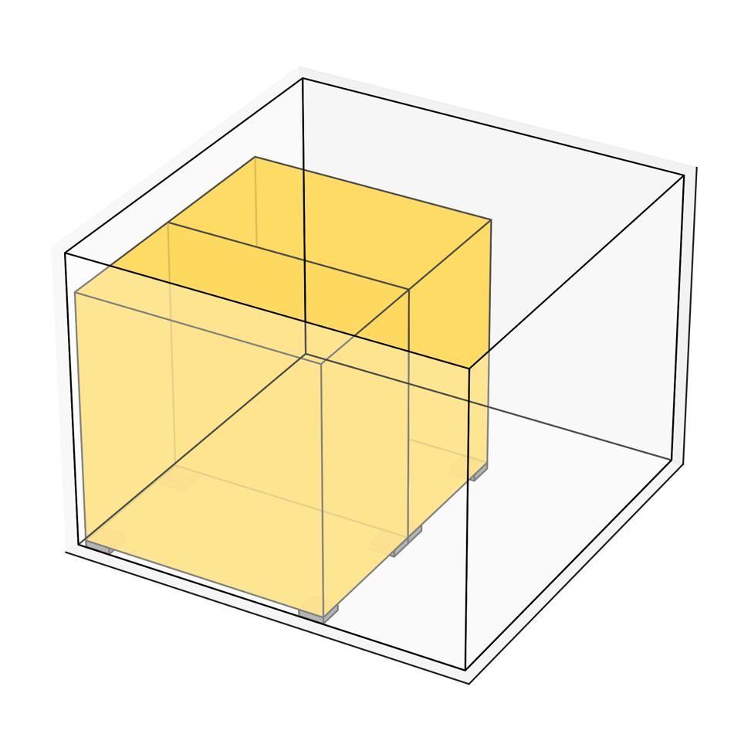
A bounded region can be visualized as a portion of space enclosed within finite limits. The enclosing surface separates the region from points outside it.
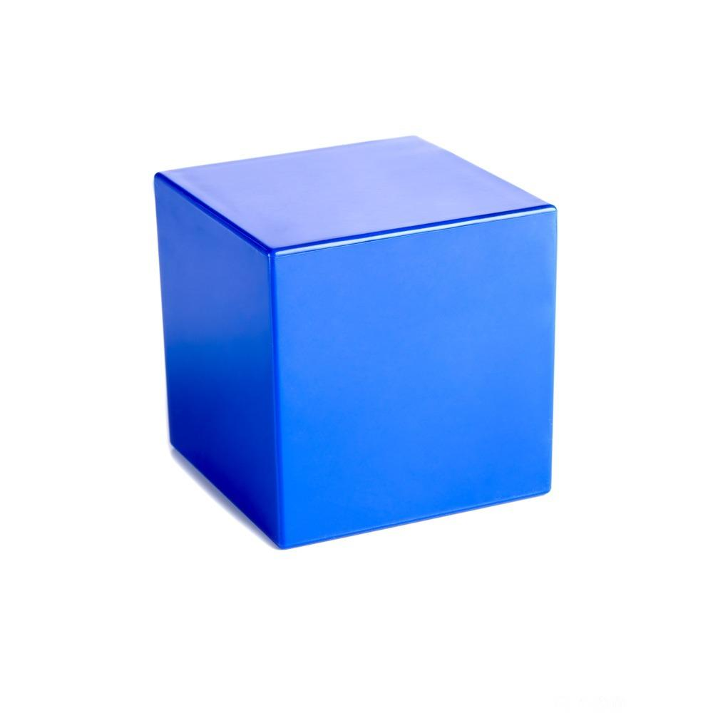
Cube-shaped region
A cube has finite length, width, and height. Its interior is bounded by six square faces.
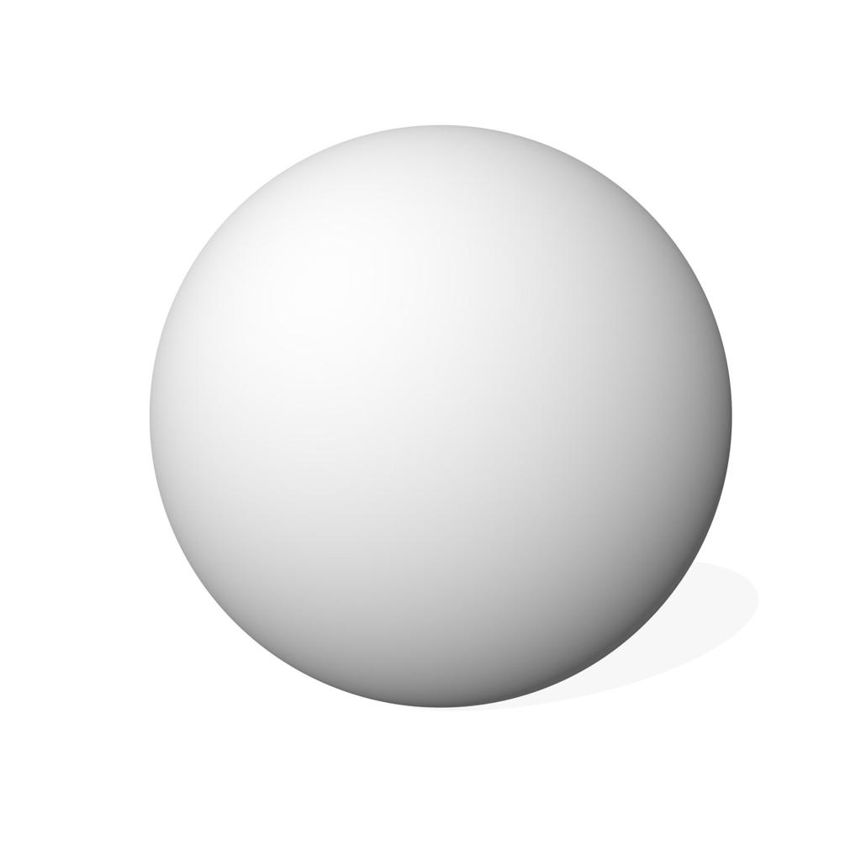
Spherical region
The region inside a sphere's surface lies within a finite distance of its center.
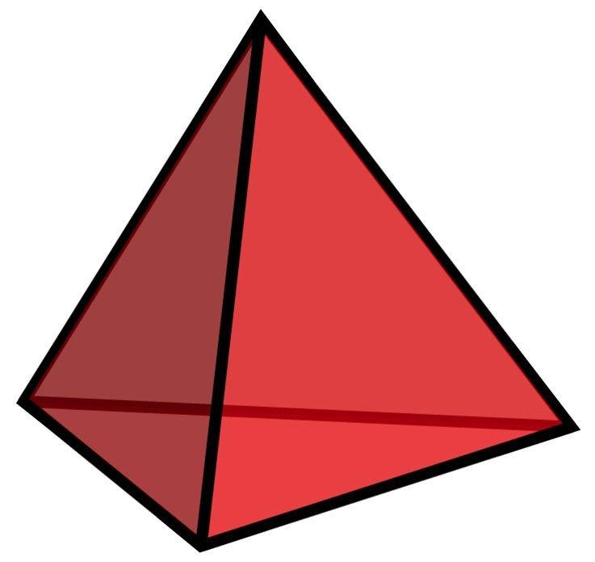
Polyhedral region
A tetrahedron encloses a finite region of space using four triangular faces.

Mathematical Representation

General definition of boundedness
# Source: AI Source: Provided by: [Data Path: Persons Table -> ID Column: 1, Name_En Column: Motasem Essam] -> From: [ChatGPT] on [7/25/2026]
Let $R$ be a region in three-dimensional Cartesian space. The region is bounded if there exists a finite number $M>0$ and a fixed point $P_{0}$ such that every point $P$ in the region satisfies
$$\operatorname{dist}\left(P,P_{0}\right)≤M$$
If $P=\left(x,y,z\right)$ and $P_{0}=\left(a,b,c\right)$, then
$$\sqrt{{\left(x-a\right)}^{2}+{\left(y-b\right)}^{2}+{\left(z-c\right)}^{2}}≤M$$
This means that the entire region fits inside a sphere of finite radius $M$ centered at $P_{0}$.

Example: A bounded cube
# Source: AI Source: Provided by: [Data Path: Persons Table -> ID Column: 1, Name_En Column: Motasem Essam] -> From: [ChatGPT] on [7/25/2026]
A cube-shaped region can be described by
$$0≤x≤4, 0≤y≤4, 0≤z≤4$$
Every coordinate is restricted to a finite interval. Therefore, the region is bounded.
Its volume is
$$V=s^{3}=4^{3}=64$$
cubic units.

6.3 Example: A bounded spherical region
# Source: AI Source: Provided by: [Data Path: Persons Table -> ID Column: 1, Name_En Column: Motasem Essam] -> From: [ChatGPT] on [7/25/2026]
A closed ball centered at the origin with radius $r$ is described by
$$x^{2}+y^{2}+z^{2}≤r^{2}$$
Every point lies at a distance no greater than $r$ from the origin. Thus, the region is bounded.
Its volume is
$$V=\frac{4}{3}πr^{3}$$

6.4 Example: An unbounded region for comparison
# Source: AI Source: Provided by: [Data Path: Persons Table -> ID Column: 1, Name_En Column: Motasem Essam] -> From: [ChatGPT] on [7/25/2026]
Consider the half-space
$$z≥0$$
There is no finite distance that contains every point in this region. Points can extend arbitrarily far in the positive $z$-direction and in the horizontal directions. Therefore, this region is unbounded.

Worked Examples
# Source: AI Source: Provided by: [Data Path: Persons Table -> ID Column: 1, Name_En Column: Motasem Essam] -> From: [ChatGPT] on [7/25/2026]
Example 1: Determine whether a cube-shaped region is bounded
Suppose a region is defined by
$$0≤x≤3, 0≤y≤3, 0≤z≤3$$
Solution:
All three coordinates are restricted to values between $0$ and $3$. No point in the region can extend beyond these limits.
The region is therefore bounded.
Its volume is
$$V=3^{3}=27$$
cubic units.
Example 2: Determine whether a spherical region is bounded
Consider the region
$$x^{2}+y^{2}+z^{2}≤16$$
Solution:
The inequality describes a closed ball centered at the origin with radius $4$.
Every point is at most $4$ units from the origin. Therefore, the region is bounded.
Its volume is
$$V=\frac{4}{3}π{\left(4\right)}^{3}=\frac{256π}{3}$$
cubic units.
Example 3: Determine whether a region is bounded
Consider the region
$$x≥0, y≥0, z≥0$$
Solution:
Each coordinate can increase without limit. For example, points such as $\left(100,100,100\right)$ and $\left(1000,1000,1000\right)$ belong to the region.
There is no finite sphere that contains every point in this region.
Therefore, the region is unbounded.
Example 4: A bounded region without its boundary
Consider the open ball
$$x^{2}+y^{2}+z^{2}<9$$
Solution:
The inequality describes all points strictly inside a sphere of radius $3$, excluding the spherical surface.
Every point is less than $3$ units from the origin. Thus, the region is bounded, even though it does not include its boundary.
Its volume is still
$$V=\frac{4}{3}π{\left(3\right)}^{3}=36π$$
cubic units. Excluding the surface does not change the volume.

Comparison With Related Concepts
# Source: AI Source: Provided by: [Data Path: Persons Table -> ID Column: 1, Name_En Column: Motasem Essam] -> From: [ChatGPT] on [7/25/2026]
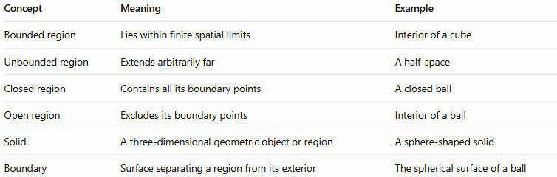
Concept | Meaning | Example
Bounded region | Lies within finite spatial limits | Interior of a cube
Unbounded region | Extends arbitrarily far | A half-space
Closed region | Contains all its boundary points | A closed ball
Open region | Excludes its boundary points | Interior of a ball
Solid | A three-dimensional geometric object or region | A sphere-shaped solid
Boundary | Surface separating a region from its exterior | The spherical surface of a ball
Remember: Boundedness and openness or closedness describe different properties. A region may be bounded and open, bounded and closed, or unbounded and open or closed.

Applications
# Source: AI Source: Provided by: [Data Path: Persons Table -> ID Column: 1, Name_En Column: Motasem Essam] -> From: [ChatGPT] on [7/25/2026]
- Geometry: Classifying three-dimensional regions according to their spatial extent.
- Volume calculation: Identifying finite regions for which volume formulas or integrals can be applied.
- Computer graphics: Defining finite objects and calculating their bounding boxes.
- Engineering: Describing the finite spatial limits of components and structures.
- Calculus: Studying domains of integration and evaluating triple integrals.
- Physics: Modeling finite physical objects and distinguishing them from idealized infinite spaces.

Key Points
# Source: AI Source: Provided by: [Data Path: Persons Table -> ID Column: 1, Name_En Column: Motasem Essam] -> From: [ChatGPT] on [7/25/2026]
- A bounded region occupies a finite extent of three-dimensional space.
- A region is bounded if all its points lie within some sphere of finite radius.
- Cubes, tetrahedra, and balls are common examples of bounded regions.
- A half-space and all of three-dimensional space are unbounded.
- A bounded region does not have to include its boundary.
- Boundedness alone does not guarantee a regular shape or a well-defined volume without additional mathematical conditions.

Conclusion
# Source: AI Source: Provided by: [Data Path: Persons Table -> ID Column: 1, Name_En Column: Motasem Essam] -> From: [ChatGPT] on [7/25/2026]
A bounded region in solid geometry is a portion of three-dimensional space that cannot extend arbitrarily far from a fixed point. It may be enclosed by flat or curved surfaces and may include or exclude its boundary. Understanding bounded regions is fundamental to classifying geometric spaces, calculating volumes, and studying three-dimensional objects.

